

Executive Assistant

Information for applicants

Executive Assistant | Closing date for applications:  Monday 28 August 2017  Interview date:  8 September 2017

Dear Applicant,

Thank you for your interest in the position of Executive Assistant with the County Councils Network (CCN).

CCN is the national representative body for county and county unitary authorities, at the cutting edge of the debate on the future of public services in England. CCN is a member-led organisation which develops policy, undertakes innovative research and makes representations to government. We also provide a range of support services to councils and promote service innovation through the sharing of best practice. CCN is a special interest group of the Local Government Association (LGA).For more information about CCN please look at our website www.countycouncilsnetwork.org.uk

As the Executive Assistant, you will be responsible for supporting the CCN Director and wider CCN Team in delivering effective business practices, providing administrative and clerical support to assist in the delivery of CCN’s policy, research, public affairs and communications activity. You will provide the point of contact for CCN’s member authorities and councillors, and ensure the delivery of CCN’s portfolio of meetings, conferences and events.

The ideal candidate will be someone with:-

- Excellent administrative and written skills, highly organised and with experience of a range of office software (ICT)
- Excellent interpersonal skills, with the ability to deal with councillors, other clients and colleagues with courtesy, tact and sensitivity.
- Political sensitivity, with the ability to exercise discretion, judgement and confidentiality when dealing with politicians and officers at every level, and to demonstrate political neutrality at all times. Experience related to local government would be beneficial.
- The ability to work as part of a team, with a keenness to adapt to meet changing requirements.

We are a small organisation looking for an enthusiastic person with excellent organisational skills and the ability to prioritise work to meet competing deadlines. If you would like further information please contact victoria.moloney@local.gov.uk
We look forward to receiving your application.

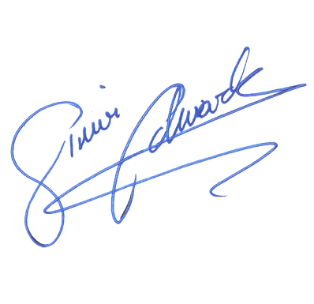

Simon Edwards
Director CCN

Job Description: Executive Assistant

Job title: Executive Assistant – 1 Year Fixed Term Contract (with possibility to extend contract after initial year)

Grade : Grade 2 (SCP006) from £24,134 including London Weighting

Responsible to: Public Affairs Officer and CCN Director

Job purpose: To act as PA to the CCN Director and support the effective and efficient management of CCN business processes, including Annual Conference, general administration, meetings and events, and member/stakeholder information.

Key contacts: CCN team, Lead members, chief executives, PAs, external contacts and partner organisations.

Principal Accountabilities

1. To act as PA to the Director and first point of contact for CCN, providing administrative and clerical support to the CCN team.

2. To ensure the CCN Finance Officer is given all relevant information and documentation required for maintaining CCN financial records.

3. Supporting the Public Affairs Officer with parliamentary events and outreach including activities with the County All-Party Parliamentary Group (APPG).

4. To support the Director and other CCN Staff in the organisation and running of CCN Conference, seminars and other events.

5. To organise and manage the programme of CCN meetings including preparation of agendas, distribution of papers, and preparation of minutes.

6. To provide an effective office administration service including printing, photocopying, transport, accommodation, room bookings, ordering stationery and supplies.

7. To support the Director in managing HR functions such as recruitment administration, personnel files, leave calculations and sickness records.

8. To maintain CCN’s stakeholder data including CCN member information, to develop new data as needed to support CCN business.

9. Any other duties relating to the effective and efficient running of CCN as directed by the Public Affairs Officer and the CCN Director.

Person specification

We are a small organisation looking for an enthusiastic person with excellent organisational skills and the ability to prioritise work to meet competing deadlines.

Knowledge and Experience
• Previous administrative experience and knowledge of office systems (desirable).
• Experience of working within a team environment.
• Experience of a range of software packages including Microsoft Word, Excel, Access, and PowerPoint, or a willingness to learn.
• Experience of organising meetings, events or other activities.

Skills and abilities
• Excellent written skills
• Political sensitivity, with the ability to exercise discretion, judgement and confidentiality when dealing with politicians and officers at every level, and to demonstrate political neutrality at all times.
• Good interpersonal skills, with the ability to deal with members, other clients and colleagues with courtesy, tact and sensitivity.
• Excellent organisational skills, with the ability to prioritise work to meet deadlines, and a concern for order and accuracy.
• Excellent IT skills, including Microsoft Word, Excel, Access, PowerPoint with the ability quickly to learn new packages as required.
• Ability to work as part of a team and to support others.
• Flexible approach to work, with a keenness to adapt to meet changing work requirements.
• A positive, “can do” attitude.

To apply, please send a CV and covering letter of no more than 1200 words to victoria.moloney@local.gov.uk Further detail on the role is provided below.

The covering letter should include any experience, skills, knowledge or achievements from any areas of work or personal life which relate to the criteria contained in the person specification.

To discuss this job opportunity further, or for any additional queries please email Victoria.moloney@local.gov.uk or call 0207 664 3019

Successful candidates will be invited to interview on Friday 8th September 2017.

Recruitment process

Application Form

Those applying for the role are asked to provide a CV and cover letter of no more than 1200 words, detailing any experience relevant to this post. Include any experience, skills, knowledge or achievements from any areas of work or personal life which relate to the criteria contained in the person specification.

Selection and Assessment Process

Shortlisting will take place after the closing date and shortlisted candidates will be invited to an interview on 8 September 2017. Whilst we will do our best to offer an alternative date this is not always possible in every case.

Please note if you have not heard from us by within 4 weeks of the closing date your application has been unsuccessful on this occasion.

About CCN

The County Councils Network (CCN) represents 37 English councils that serve county and county unitary councils who together have over 2500 councillors and serve over 23 million people (47% of the population) across 86% of England.

CCN develops policy, shares best practice and advocates policy solutions to Government on behalf of this significant proportion of the country outside the big conurbations.

CCN is a member-led organisation which works on an inclusive and all party basis and seeks to make representations to government which can be supported by all member councils.

CCN is a special interest group of the Local Government Association (LGA). For more information about CCN please check out our website www.countycouncilsnetwork.org.uk

Benefits and conditions
Full details will be provided to the successful candidate

Working for the CCN
The post will be employed directly by CCN with payroll and pension services provided by Lancashire County Council. CCN adopts the LGA’s terms and conditions.
Employment terms
CCN is offering this position on an initial fixed term contract of one year with a view to the position becoming permanent at the end of the contract.

Salary
The starting salary for this post is £24,134 per annum including London Weighting (This includes the anticipated 1% national pay award for 2016/17).

Hours of work

Your hours of work will be 35 hours per week.

Annual leave and statutory holidays
Your annual leave entitlement will be circa 28 days. In addition to annual leave, you will be entitled to statutory holidays occurring during your contract. In the first and last years of service, members of staff are entitled to annual leave proportionate to the completed months of service in that year.

Whole time service
You will be expected to devote your whole time service to the work of the CCN and you shall not engage in any other business or take up any other appointment without the approval of the Director.

Political impartiality
Although CCN posts are not subject to the same political restrictions as local authorities, members of staff will be expected to behave in ways, which express clear political impartiality and will not be able to take up any public political office without the approval of the Director.

Sickness payments
The CCN applies the scheme agreed by the National Joint Council (NJC) for Local Government Services.

Pension
You have the opportunity to join the Local Government Pension Scheme. Details will be given to the successful candidate.

Season ticket loan
All employees may apply for an interest-free season ticket loan to assist in their travel to and from work.

Equal opportunities
The CCN is committed to providing equal opportunities for existing and potential members of staff. It is a condition of employment that all members of staff comply with the equality and diversity policy.

Location
The County Councils Network is temporarily based at Layden House, Turnmill Street, Farringdon, EC1M 5LG. However, the successful candidate will move with the rest of the office to our usual residence at Local Government House, Smith Square, Westminster during the autumn.

Both Layden House and Local Government House offer tea and coffee points and quiet rooms on each floor, meeting rooms, staff rooms, bicycle storage facilities and shower facilities. Maps for both locations are provided below.
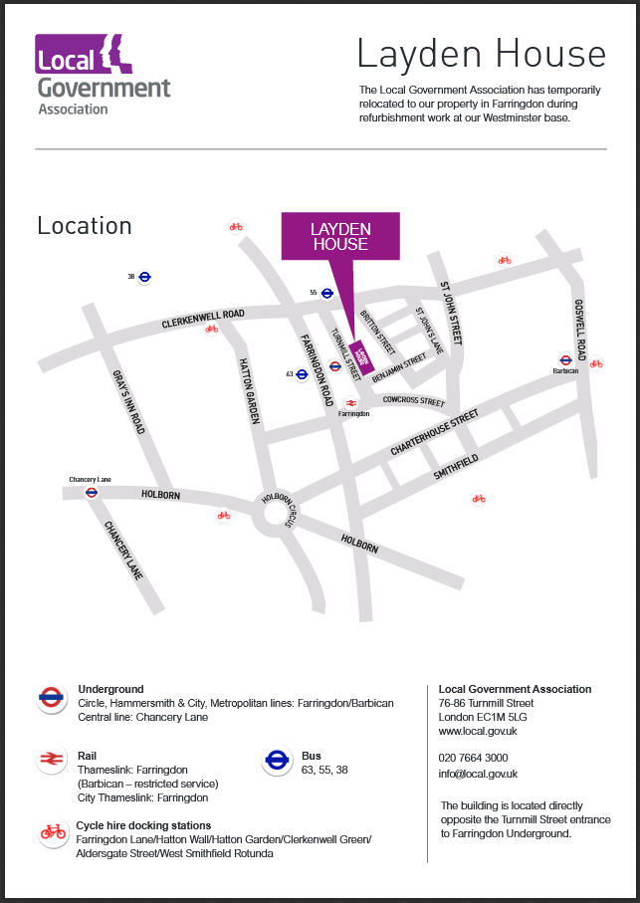
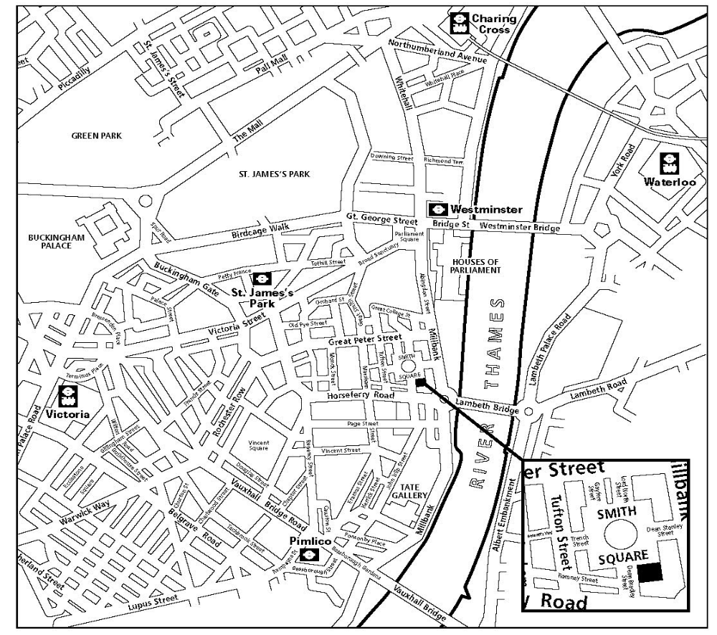
Location map
Local Government House,  (Formerly known as Transport House),  Smith Square, London SW1P 3HZ  Public transport  Local Government House is well served by public transport. The nearest mainline stations are Victoria and Waterloo; the local underground stations are St James’s Park (Circle and District Lines); Westminster (Circle, District and Jubilee Lines); and Pimlico (Victoria Line), all about 10 minutes walk away.  Buses 3 and 87 travel along Millbank and the 507 between Victoria and Waterloo goes close by at the end of Dean Bradley Street.  Bus route – Millbank  87 Wandsworth - Aldwych  3 Crystal Palace - Brixton - Oxford Circus | Bus routes - Horseferry Road  507 Waterloo - Victoria  C10 Canada Water - Pimlico - Victoria  88 Camden Town - Whitehall - Westminster -  Pimlico - Clapham Common  Central London Congestion Charging Zone  Local Government House is located within the  congestion charging zone. For further details,  please call 0845 900 1234 or visit the website at  www.cclondon.com  Car Parks  Abingdon Street Car Park  Great College Street  Horseferry Road Car Park  Horseferry Road/Arneway Street

